**DLD Lab 06 – Home Tasks**

**Task 02 (a):**

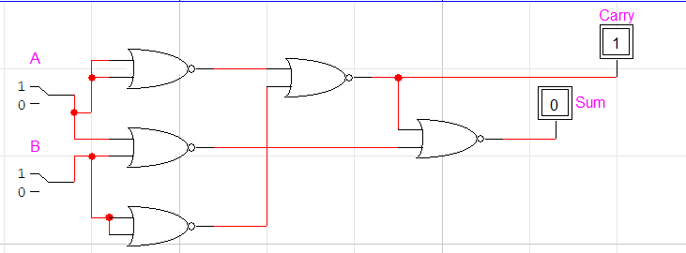

|  |  |  |  |
| --- | --- | --- | --- |
| **A** | **B** | **Sum** | **Carry** |
| 0 | 0 | 0 | 0 |
| 0 | 1 | 1 | 0 |
| 1 | 0 | 1 | 0 |
| 1 | 1 | 0 | 1 |

**Task 02(b):**

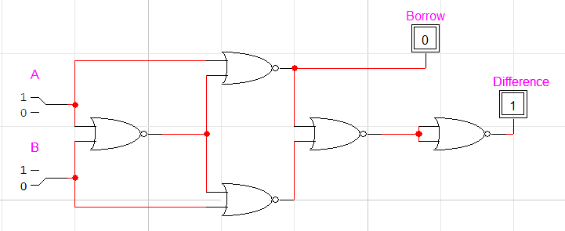

|  |  |  |  |
| --- | --- | --- | --- |
| **A** | **B** | **Difference** | **Borrow** |
| 0 | 0 | 0 | 0 |
| 0 | 1 | 1 | 1 |
| 1 | 0 | 1 | 0 |
| 1 | 1 | 0 | 0 |

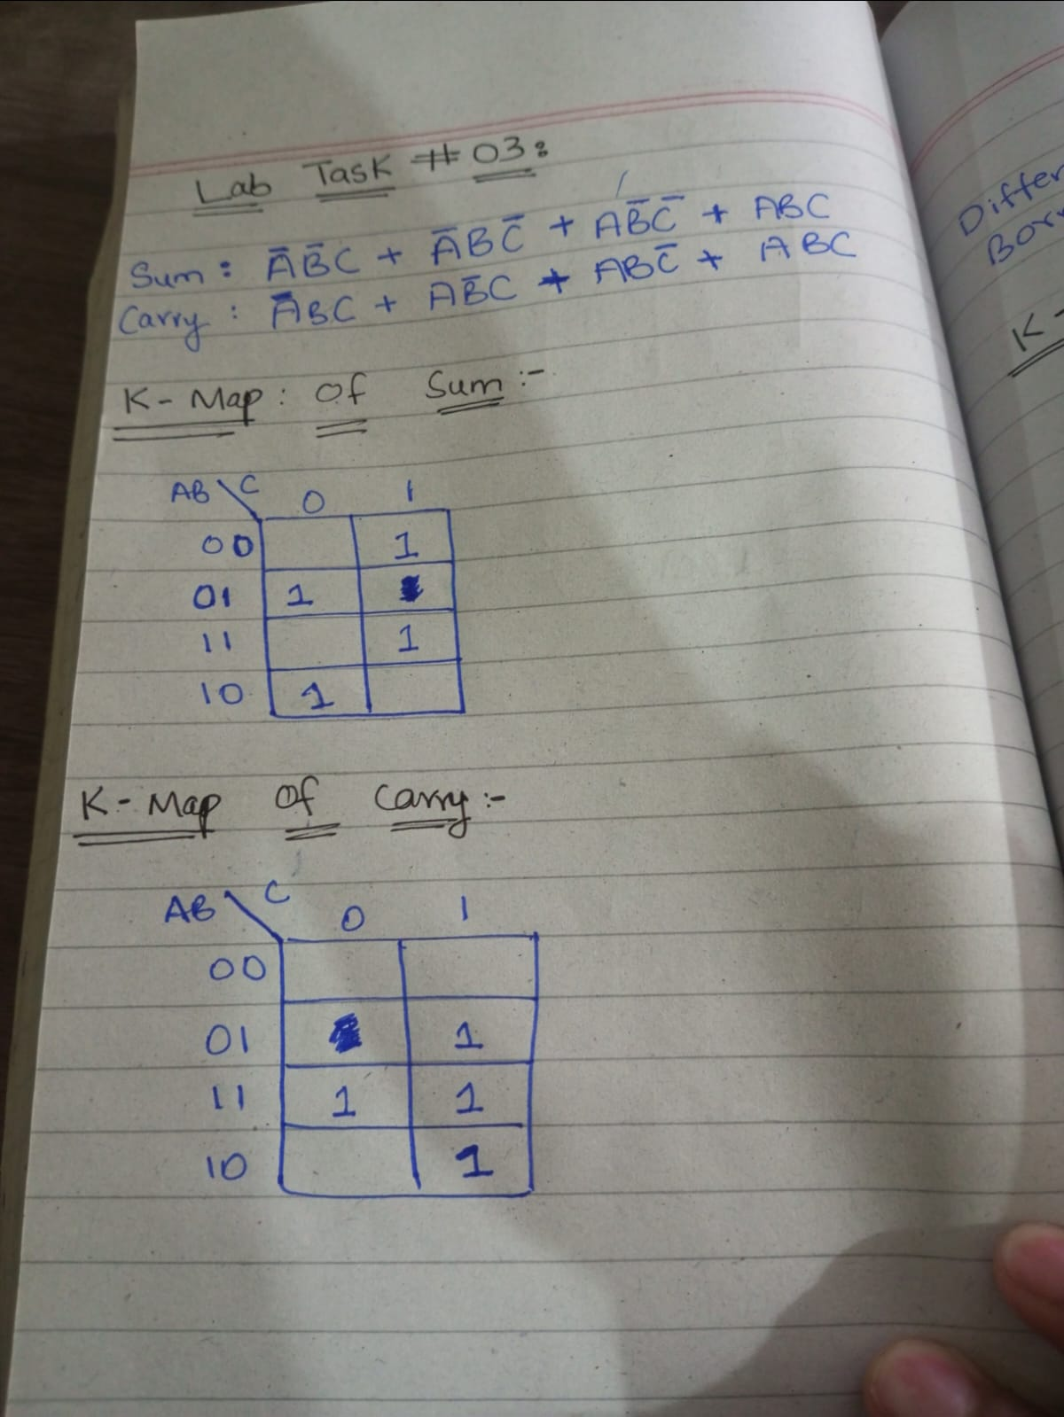**Task 03:**

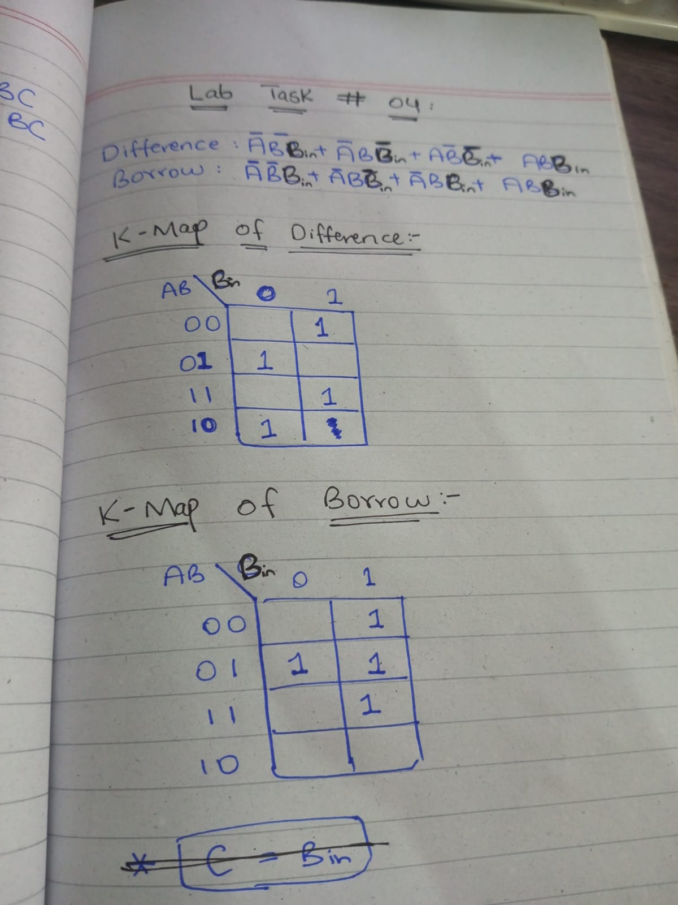**Task 04:**